ECEN240

Lab 1 Part 1 – Simple LED Circuit

Construct the circuit shown below on a breadboard (protoboard) following the instructions below:

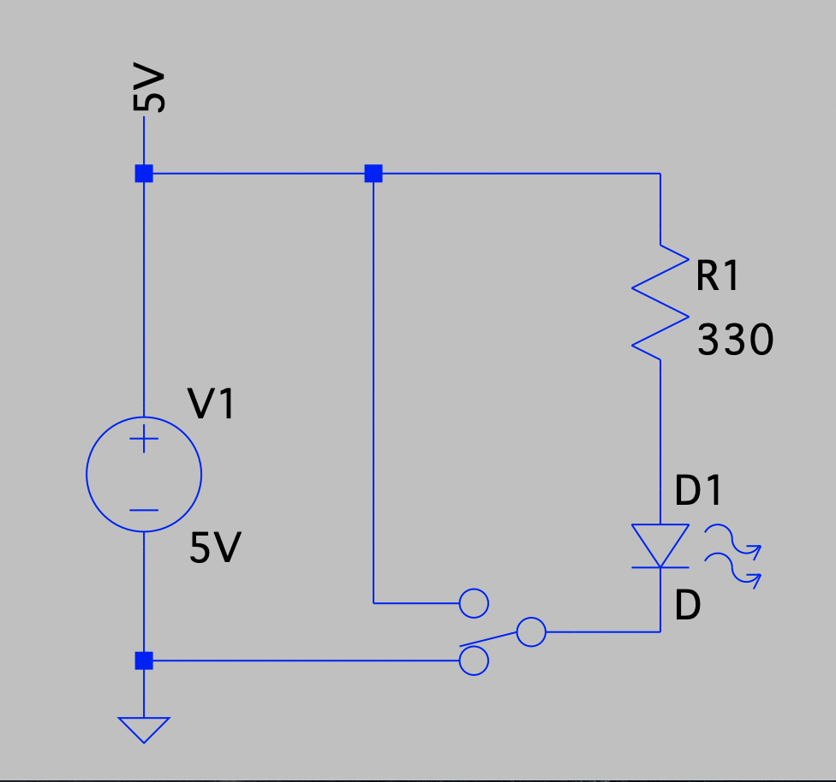

The components and wires needed are in the parts bin shown below. The parts bins also have batteries and resistors that will not be used. Use only components from your parts bin for measurements.



Step 1 - Verify that you have the following components:



Step 2 - Assemble the tools that will be used to construct this circuit. You will need the Digital Multi-Meter (DMM), 2 sets of banana connectors with alligator clips on one end, a breadboard and possibly wire strippers and needle nose pliers.

Step 3 - Insert the switch into the breadboard and insert the power and ground wires as shown:

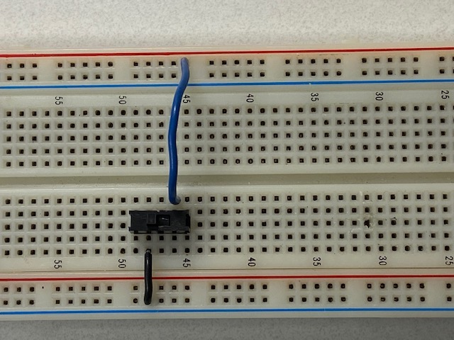

Step 4 - Insert the LED into the breadboard. The LED will only conduct current if it is oriented correctly.

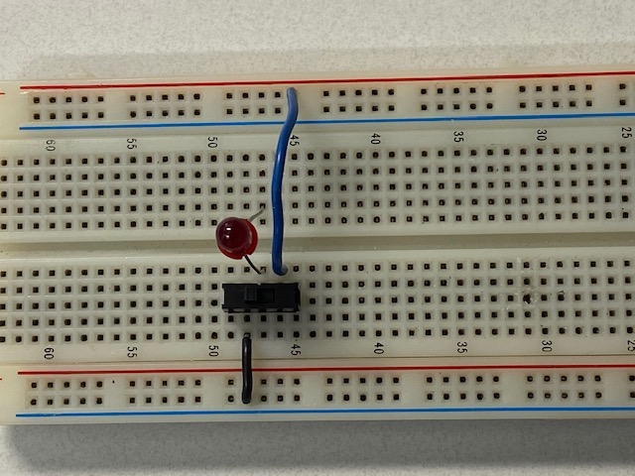

Step 5 - Insert the resistor:

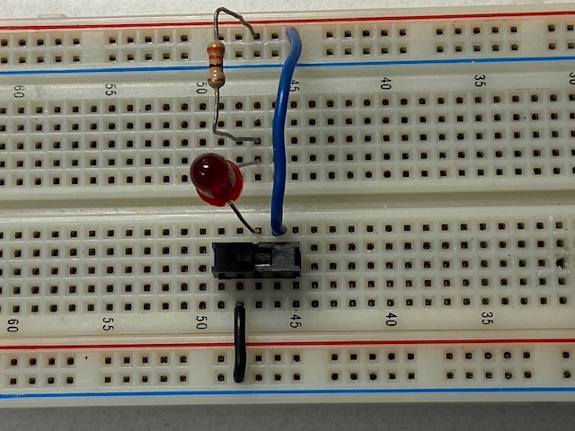

Step 6 – Connect the power and ground wires and clip on the alligator side of the leads:

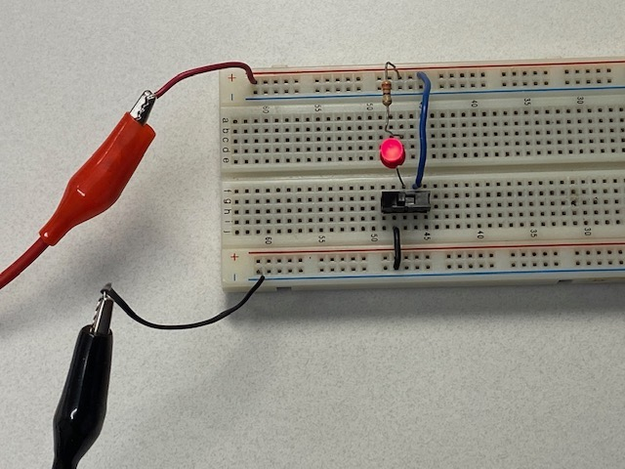

Step 7 – Connect the banana connector ends of the leads to the power supply and push the power button to turn on the supply. Please note that this voltage shown in green is not the voltage of the connectors on the far right. These connectors are always 5V. Don’t use the other connectors because this could cause damage to the LED.

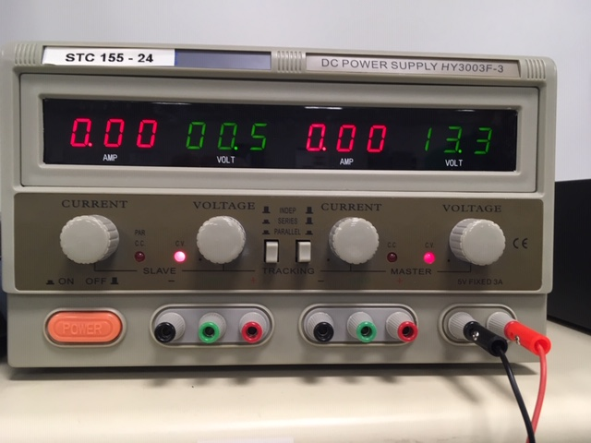

Now you are ready to test the circuit by turning on the switch. Once you have verified that it is functioning, proceed to answer the questions of the quiz.